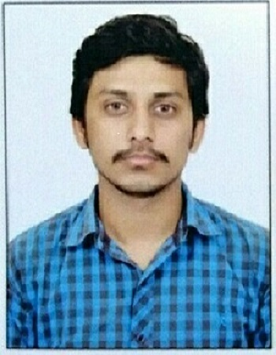 | Name: Rajat Rana  Designation (Subject) : Assistant professor (Physics)  E mail: rajat.rana892@gmail.com  Qualification : Msc (Physics), CSIR-NET, HP-SET,  Ph.D.:- Pursuing  Total Teaching Experience: 11

OP/RC/Training Programmes/Workshops attended/papers presented in conferences/Seminars, Publications etc.
- Orientation Programme attended = 01
- Refresher Courses attended = Nil
- Papers published in International Journal: 05
- Papers published in National Journal: Nil
- Papers published in conference Proceedings: 03
- Published chapter in Book = Nil
- Books published (Text and reference)
- Conferences/ Seminars paper presentation = 04
- Trainings / STC / workshops attended = Nil
- Any other information =

Member of professional body / Society /Honours/Awards/Recognitions:

