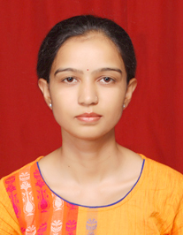 | Name: Dr. K. Seema  Designation (Subject) : Assistant Professor, Physics  E mail: seemachoudhary077@gmail.com  Qualification : M.Sc., M.Phil, Ph.D., JRF-NET  Total Teaching Experience: 13 years

OP/RC/Training Programmes/Workshops attended/papers presented in conferences/Seminars, Publications etc.
- Orientation Programme attended = 01
- Refresher Courses attended = 02
- Papers published in International Journal=09
- Papers published in National Journal=01
- Papers published in conference Proceedings=07
- Published chapter in Book = 01
- Books published (Text and reference)=Nil
- Conferences/ Seminars paper presentation = 11
- Trainings / STC / workshops attended = 05
- Any other information =

Member of professional body / Society /Honours/Awards/Recognitions:
- Member of Indian Physics Association

