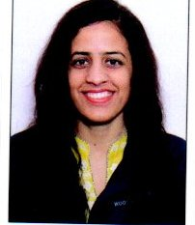  Photograph | Name: Rekha  Designation (Subject) : Zoology  E mail: tapasvirekha03@gmail.com  Qualification: M.Phil., MSc, B.Ed. and BSc.(PhD pursuing)  Total Teaching Experience: 06 years (11.04.2023 to till date)

OP/RC/Training Programmes/Workshops attended/papers presented in conferences/Seminars, Publications etc.
- Orientation Programme attended = 01
- Refresher Courses attended = 01(Zoology)
- Papers published in International Journal: 00
- Papers published in National Journal: 01( Biotechnological Techniques – DNA Barcoding,RNAI, SIT and Biopesticides in Insect Pest Management for Sustainable Agriculture During 21st Century).
- Papers published in conference Proceedings:
- Published chapter in Book = 00
- Books published (Text and reference)=00
- Conferences/ Seminars paper presentation = 03 National+01 International
- Trainings / STC / workshops attended = 04
- Any other information = Faculty development Programme(03)

Member of professional body / Society /Honours/Awards/Recognitions: acted as judge for District level Science Exhibition and Project Completion (7th DLEPC) under INSPIRE Scheme at Govt. Senior Sec. School Raja Ka Talab (11th to 13th Feb. 2018).
Invited as a Speaker to deliver lecture on waste management- Single Use Plastic (SUP) in one day workshop held on dated 09.05.2023 at Govt. Sr. Sec. School Raja Ka Talab.

